

**Digital Logic Lab Assignment 11**

11.1. To verify the operation of 2x4 decoder

11.2. To verify the operation of 3x8 decoder

11.3. To verify the operation of 4x16 decoder

**SUBMITTED BY:**

Gaurav Chaulagain

Year I / SEM I

017BSCIT014

**SUBMITTED TO**

|  |  |
| --- | --- |
| Er. Saugat Sigdel  Lecturer |  |
| Department of Computer Science | |

**OBJECTIVE 11:**

**THEORY:**

**Decoder:**

* It is a combinational circuit that converts binary information from n-input lines to maximum of 2n unique output lines.
* Basic function of the decoder is to detect the presence of specified combination of bits on its inputs and to indicate the presence of that code by a specified output level.
* It has n inputs and 2n outputs where only one output can be high at a time.

Its Block diagram is given below:

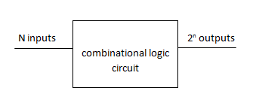

**OBJECTIVE 11.1**

**TO VERIFY THE OPERATION OF 2×4 DECODER.**

**THEORY:**

2 inputs = 22 outputs = 4 outputs, where one output is high at a time.

The Block diagram is given below:

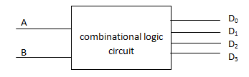

**TRUTH TABLE:**

|  |  |  |  |  |  |
| --- | --- | --- | --- | --- | --- |
| Inputs | | Outputs | | | |
| A | B | D0 | D1 | D2 | D3 |
| 0 | 0 | 1 | 0 | 0 | 0 |
| 0 | 1 | 0 | 1 | 0 | 0 |
| 1 | 0 | 0 | 0 | 1 | 0 |
| 1 | 1 | 0 | 0 | 0 | 1 |

**BOOLEAN EXPRESSION:**D0: A’.B’ D1: A’.B D2: A.B’ D3: A.B

**CIRCUIT DIAGRAM:**

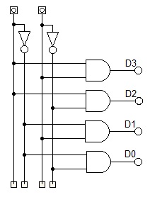

**OBSERVATION:**

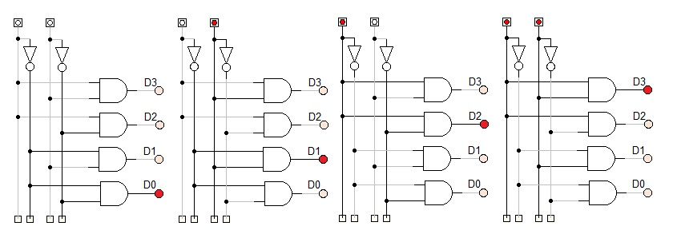

**OBSERVATION TABLE:**

|  |  |  |  |  |  |
| --- | --- | --- | --- | --- | --- |
| Inputs | | Outputs | | | |
| A | B | D0 | D1 | D2 | D3 |
| 0 | 0 | 1 | 0 | 0 | 0 |
| 0 | 1 | 0 | 1 | 0 | 0 |
| 1 | 0 | 0 | 0 | 1 | 0 |
| 1 | 1 | 0 | 0 | 0 | 1 |

**CONCLUSION:**

Hence, the operation of 2×4 Decoder was implemented.

**OBJECTIVE 11.2**

**TO VERIFY THE OPERATION OF 3×8 DECODER.**

**THEORY:**

3 inputs = 23 outputs = 8 outputs, where one output is high at a time.

The Block diagram is given below:

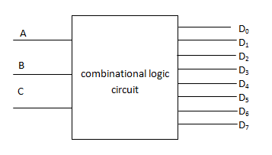

**TRUTH TABLE:**

|  |  |  |  |  |  |  |  |  |  |  |
| --- | --- | --- | --- | --- | --- | --- | --- | --- | --- | --- |
| Inputs | |  | Outputs | | | | | | | |
| A | B | C | D0 | D1 | D2 | D3 | D4 | D5 | D6 | D7 |
| 0 | 0 | 0 | 1 | 0 | 0 | 0 | 0 | 0 | 0 | 0 |
| 0 | 0 | 1 | 0 | 1 | 0 | 0 | 0 | 0 | 0 | 0 |
| 0 | 1 | 0 | 0 | 0 | 1 | 0 | 0 | 0 | 0 | 0 |
| 0 | 1 | 1 | 0 | 0 | 0 | 1 | 0 | 0 | 0 | 0 |
| 1 | 0 | 0 | 0 | 0 | 0 | 0 | 1 | 0 | 0 | 0 |
| 1 | 0 | 1 | 0 | 0 | 0 | 0 | 0 | 1 | 0 | 0 |
| 1 | 1 | 0 | 0 | 0 | 0 | 0 | 0 | 0 | 1 | 0 |
| 1 | 1 | 1 | 0 | 0 | 0 | 0 | 0 | 0 | 0 | 1 |

**BOOLEAN EXPRESSION:**D0: A’.B’.C’ D1: A’.B’.C D2: A’.B.C’ D3: A’.B.C  
D4: A.B’.C’ D5: A.B’.C D6: A.B.C’ D7: A.B.C

**CIRCUIT DIAGRAM:**

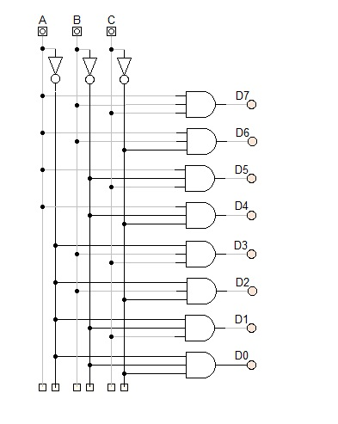

**OBSERVATION:**

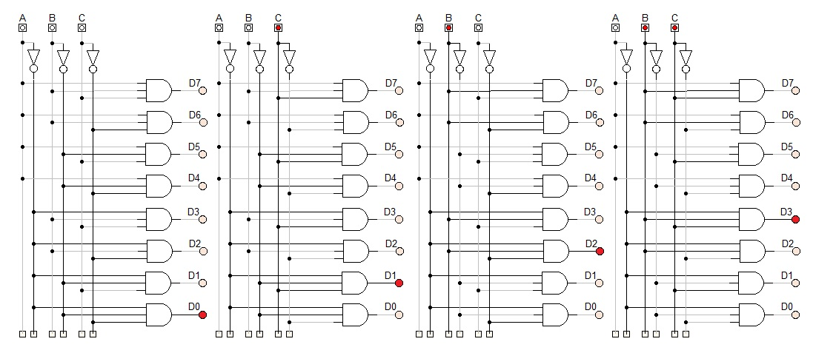

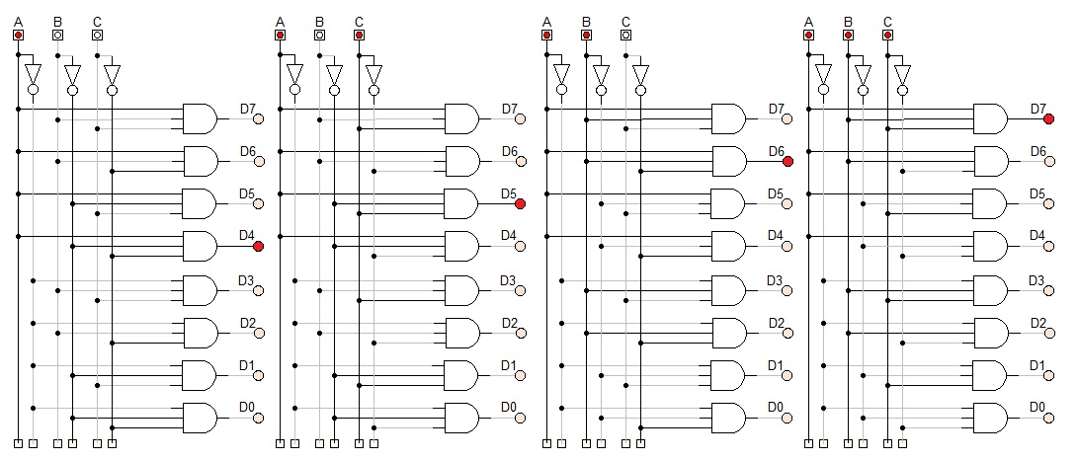

**OBSERVATION TABLE:**

|  |  |  |  |  |  |  |  |  |  |  |
| --- | --- | --- | --- | --- | --- | --- | --- | --- | --- | --- |
| Inputs | |  | Outputs | | | | | | | |
| A | B | C | D0 | D1 | D2 | D3 | D4 | D5 | D6 | D7 |
| 0 | 0 | 0 | 1 | 0 | 0 | 0 | 0 | 0 | 0 | 0 |
| 0 | 0 | 1 | 0 | 1 | 0 | 0 | 0 | 0 | 0 | 0 |
| 0 | 1 | 0 | 0 | 0 | 1 | 0 | 0 | 0 | 0 | 0 |
| 0 | 1 | 1 | 0 | 0 | 0 | 1 | 0 | 0 | 0 | 0 |
| 1 | 0 | 0 | 0 | 0 | 0 | 0 | 1 | 0 | 0 | 0 |
| 1 | 0 | 1 | 0 | 0 | 0 | 0 | 0 | 1 | 0 | 0 |
| 1 | 1 | 0 | 0 | 0 | 0 | 0 | 0 | 0 | 1 | 0 |
| 1 | 1 | 1 | 0 | 0 | 0 | 0 | 0 | 0 | 0 | 1 |

**CONCLUSION:**

Hence, the operation of 3×8 Decoder was implemented.

**OBJECTIVE 11.3**

**TO VERIFY THE OPERATION OF 4×16 DECODER.**

**THEORY:**

4 inputs = 24 outputs = 16 outputs, where one output is high at a time.

The Block diagram is given below:

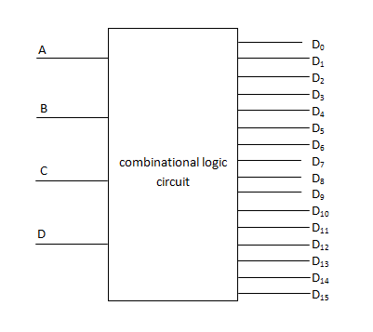

**TRUTH TABLE:**

|  |  |  |  |  |  |  |  |  |  |  |  |  |  |  |  |  |  |  |  |
| --- | --- | --- | --- | --- | --- | --- | --- | --- | --- | --- | --- | --- | --- | --- | --- | --- | --- | --- | --- |
| Inputs | | | | Outputs | | | | | | | | | | | | | | | |
| A | B | C | D | D0 | D1 | D2 | D3 | D4 | D5 | D6 | D7 | D8 | D9 | D10 | D11 | D12 | D13 | D14 | D15 |
| 0 | 0 | 0 | 0 | 1 | 0 | 0 | 0 | 0 | 0 | 0 | 0 | 0 | 0 | 0 | 0 | 0 | 0 | 0 | 0 |
| 0 | 0 | 0 | 1 | 0 | 1 | 0 | 0 | 0 | 0 | 0 | 0 | 0 | 0 | 0 | 0 | 0 | 0 | 0 | 0 |
| 0 | 0 | 1 | 0 | 0 | 0 | 1 | 0 | 0 | 0 | 0 | 0 | 0 | 0 | 0 | 0 | 0 | 0 | 0 | 0 |
| 0 | 0 | 1 | 1 | 0 | 0 | 0 | 1 | 0 | 0 | 0 | 0 | 0 | 0 | 0 | 0 | 0 | 0 | 0 | 0 |
| 0 | 1 | 0 | 0 | 0 | 0 | 0 | 0 | 1 | 0 | 0 | 0 | 0 | 0 | 0 | 0 | 0 | 0 | 0 | 0 |
| 0 | 1 | 0 | 1 | 0 | 0 | 0 | 0 | 0 | 1 | 0 | 0 | 0 | 0 | 0 | 0 | 0 | 0 | 0 | 0 |
| 0 | 1 | 1 | 0 | 0 | 0 | 0 | 0 | 0 | 0 | 1 | 0 | 0 | 0 | 0 | 0 | 0 | 0 | 0 | 0 |
| 0 | 1 | 1 | 1 | 0 | 0 | 0 | 0 | 0 | 0 | 0 | 1 | 0 | 0 | 0 | 0 | 0 | 0 | 0 | 0 |
| 1 | 0 | 0 | 0 | 0 | 0 | 0 | 0 | 0 | 0 | 0 | 0 | 1 | 0 | 0 | 0 | 0 | 0 | 0 | 0 |
| 1 | 0 | 0 | 1 | 0 | 0 | 0 | 0 | 0 | 0 | 0 | 0 | 0 | 1 | 0 | 0 | 0 | 0 | 0 | 0 |
| 1 | 0 | 1 | 0 | 0 | 0 | 0 | 0 | 0 | 0 | 0 | 0 | 0 | 0 | 1 | 0 | 0 | 0 | 0 | 0 |
| 1 | 0 | 1 | 1 | 0 | 0 | 0 | 0 | 0 | 0 | 0 | 0 | 0 | 0 | 0 | 1 | 0 | 0 | 0 | 0 |
| 1 | 1 | 0 | 0 | 0 | 0 | 0 | 0 | 0 | 0 | 0 | 0 | 0 | 0 | 0 | 0 | 1 | 0 | 0 | 0 |
| 1 | 1 | 0 | 1 | 0 | 0 | 0 | 0 | 0 | 0 | 0 | 0 | 0 | 0 | 0 | 0 | 0 | 1 | 0 | 0 |
| 1 | 1 | 1 | 0 | 0 | 0 | 0 | 0 | 0 | 0 | 0 | 0 | 0 | 0 | 0 | 0 | 0 | 0 | 1 | 0 |
| 1 | 1 | 1 | 1 | 0 | 0 | 0 | 0 | 0 | 0 | 0 | 0 | 0 | 0 | 0 | 0 | 0 | 0 | 0 | 1 |

**BOOLEAN EXPRESSION:**D0: A’.B’.C’.D’ D1: A’.B’.C’.D D2: A’.B’.C.D’ D3: A’.B’.C.D

D4: A’.B.C’.D’ D5: A’.B.C’.D D6: A’.B.C.D’ D7: A’.B.C.D

D8: A.B’.C’.D’ D9: A.B’.C’.D D10: A.B’.C.D’ D11: A.B’.C.D

D12: A.B.C’.D’ D13: A.B.C’.D D14: A.B.C.D’ D15: A.B.C.D

**CIRCUIT DIAGRAM**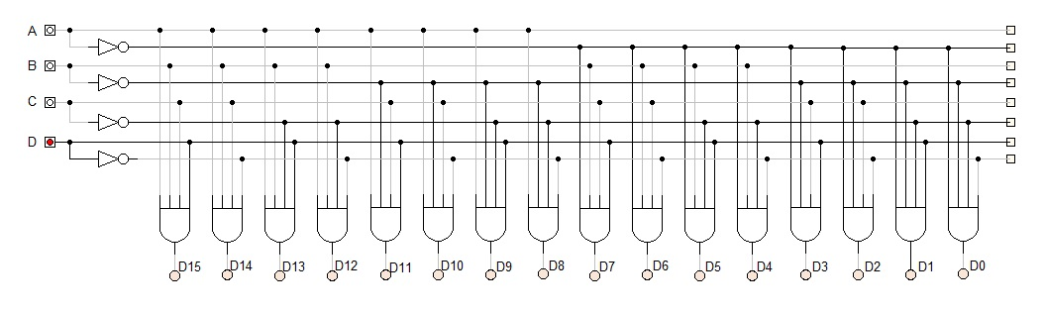

**OBSERVATION:**

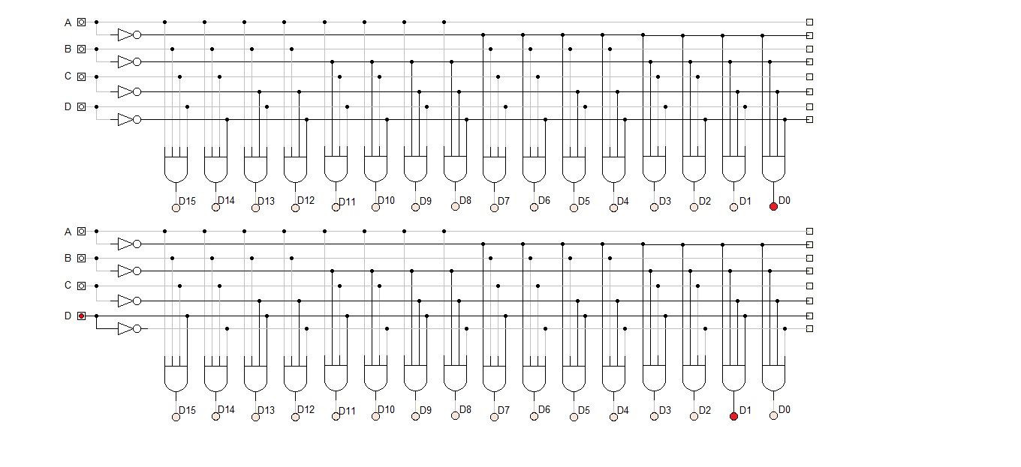

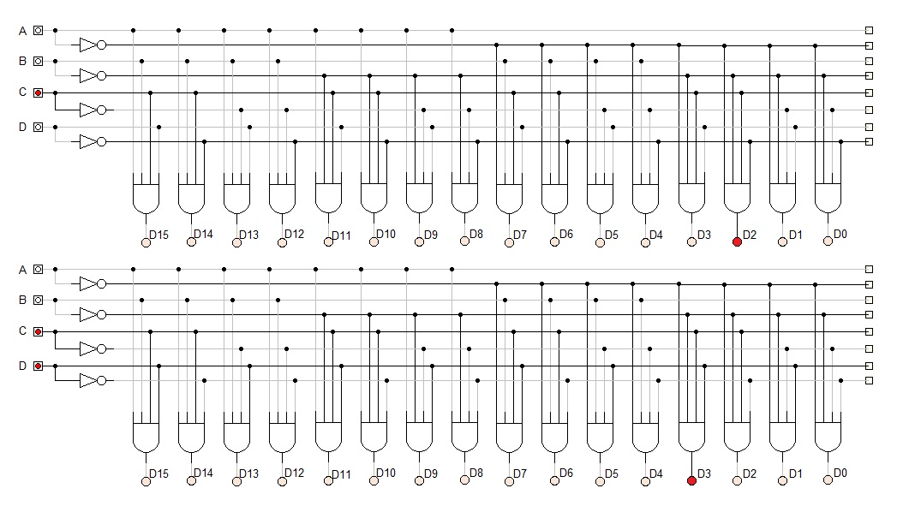

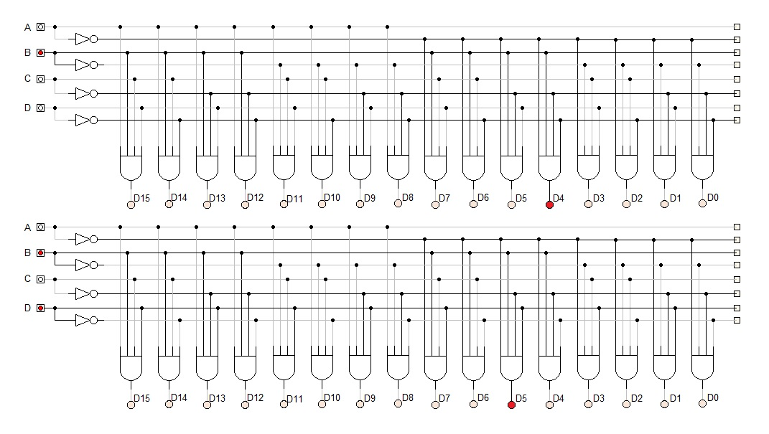

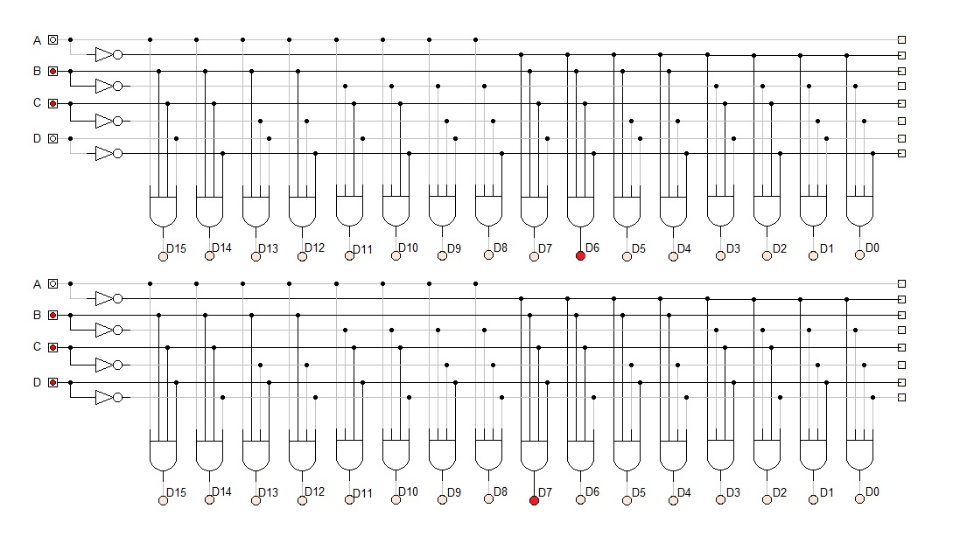

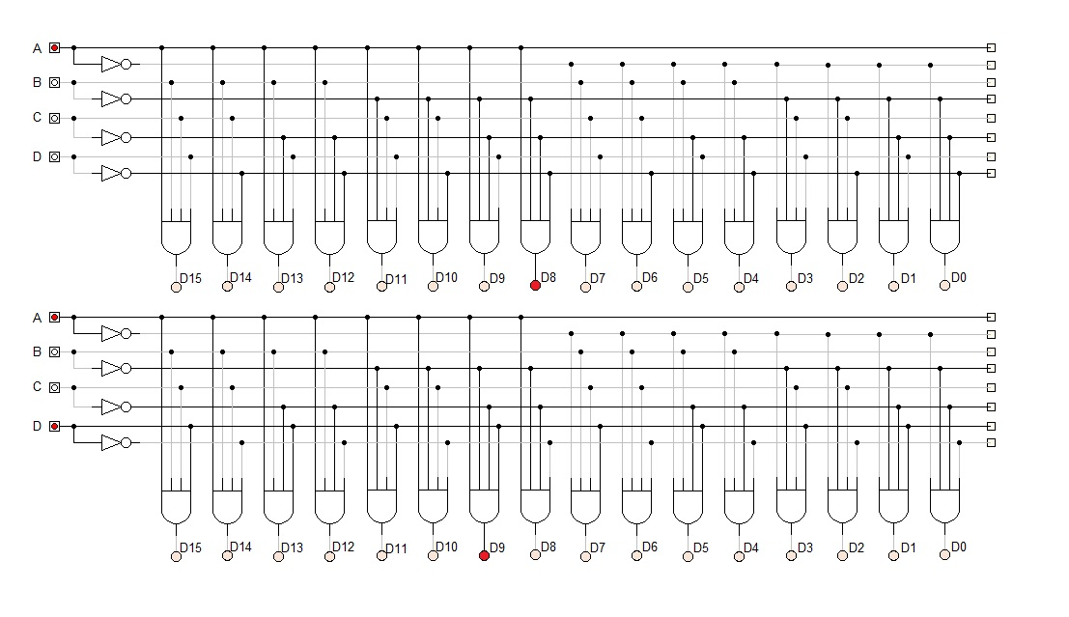

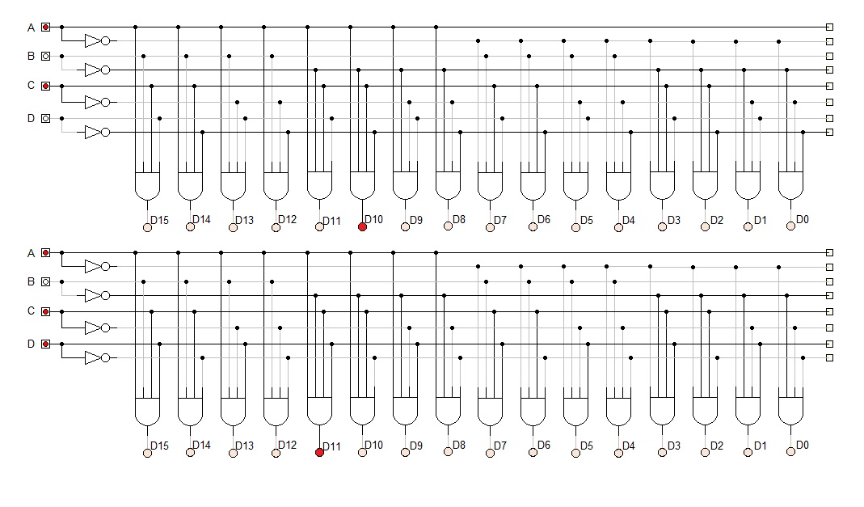

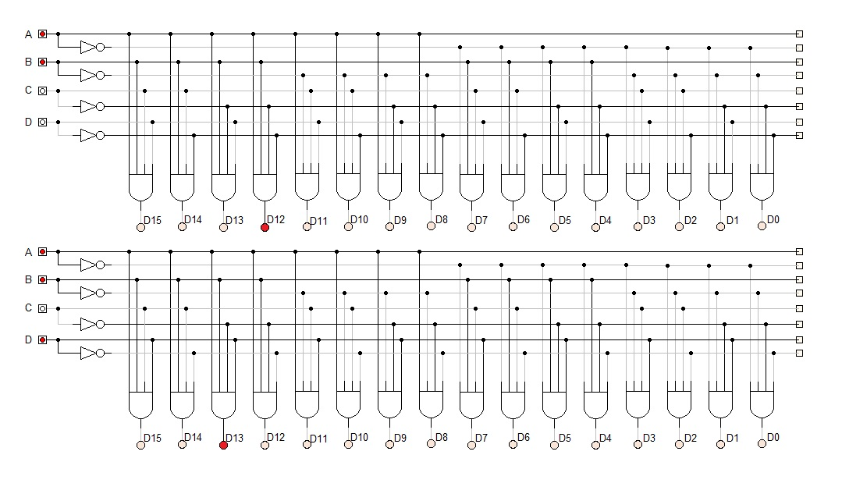

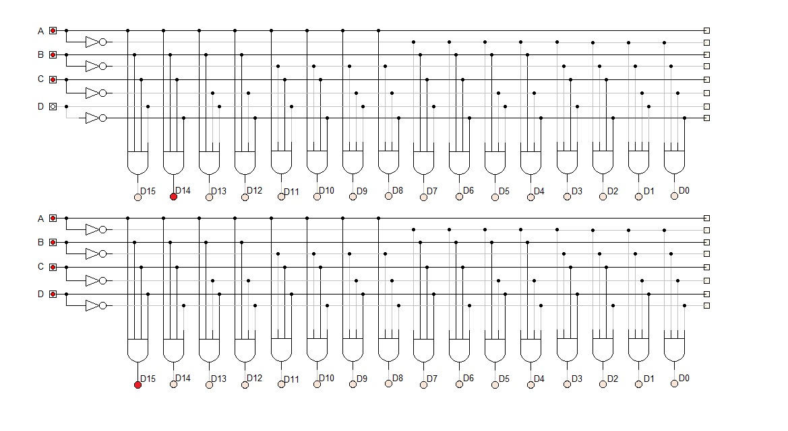

**OBSERVATION TABLE:**

|  |  |  |  |  |  |  |  |  |  |  |  |  |  |  |  |  |  |  |  |
| --- | --- | --- | --- | --- | --- | --- | --- | --- | --- | --- | --- | --- | --- | --- | --- | --- | --- | --- | --- |
| **Inputs** | | | | **Outputs** | | | | | | | | | | | | | | | |
| A | B | **C** | **D** | **D0** | **D1** | **D2** | **D3** | **D4** | **D5** | **D6** | **D7** | **D8** | **D9** | **D10** | **D11** | **D12** | **D13** | **D14** | **D15** |
| 0 | 0 | 0 | 0 | 1 | 0 | 0 | 0 | 0 | 0 | 0 | 0 | 0 | 0 | 0 | 0 | 0 | 0 | 0 | 0 |
| 0 | 0 | 0 | 1 | 0 | 1 | 0 | 0 | 0 | 0 | 0 | 0 | 0 | 0 | 0 | 0 | 0 | 0 | 0 | 0 |
| 0 | 0 | 1 | 0 | 0 | 0 | 1 | 0 | 0 | 0 | 0 | 0 | 0 | 0 | 0 | 0 | 0 | 0 | 0 | 0 |
| 0 | 0 | 1 | 1 | 0 | 0 | 0 | 1 | 0 | 0 | 0 | 0 | 0 | 0 | 0 | 0 | 0 | 0 | 0 | 0 |
| 0 | 1 | 0 | 0 | 0 | 0 | 0 | 0 | 1 | 0 | 0 | 0 | 0 | 0 | 0 | 0 | 0 | 0 | 0 | 0 |
| 0 | 1 | 0 | 1 | 0 | 0 | 0 | 0 | 0 | 1 | 0 | 0 | 0 | 0 | 0 | 0 | 0 | 0 | 0 | 0 |
| 0 | 1 | 1 | 0 | 0 | 0 | 0 | 0 | 0 | 0 | 1 | 0 | 0 | 0 | 0 | 0 | 0 | 0 | 0 | 0 |
| 0 | 1 | 1 | 1 | 0 | 0 | 0 | 0 | 0 | 0 | 0 | 1 | 0 | 0 | 0 | 0 | 0 | 0 | 0 | 0 |
| 1 | 0 | 0 | 0 | 0 | 0 | 0 | 0 | 0 | 0 | 0 | 0 | 1 | 0 | 0 | 0 | 0 | 0 | 0 | 0 |
| 1 | 0 | 0 | 1 | 0 | 0 | 0 | 0 | 0 | 0 | 0 | 0 | 0 | 1 | 0 | 0 | 0 | 0 | 0 | 0 |
| 1 | 0 | 1 | 0 | 0 | 0 | 0 | 0 | 0 | 0 | 0 | 0 | 0 | 0 | 1 | 0 | 0 | 0 | 0 | 0 |
| 1 | 0 | 1 | 1 | 0 | 0 | 0 | 0 | 0 | 0 | 0 | 0 | 0 | 0 | 0 | 1 | 0 | 0 | 0 | 0 |
| 1 | 1 | 0 | 0 | 0 | 0 | 0 | 0 | 0 | 0 | 0 | 0 | 0 | 0 | 0 | 0 | 1 | 0 | 0 | 0 |
| 1 | 1 | 0 | 1 | 0 | 0 | 0 | 0 | 0 | 0 | 0 | 0 | 0 | 0 | 0 | 0 | 0 | 1 | 0 | 0 |
| 1 | 1 | 1 | 0 | 0 | 0 | 0 | 0 | 0 | 0 | 0 | 0 | 0 | 0 | 0 | 0 | 0 | 0 | 1 | 0 |
| 1 | 1 | 1 | 1 | 0 | 0 | 0 | 0 | 0 | 0 | 0 | 0 | 0 | 0 | 0 | 0 | 0 | 0 | 0 | 1 |

**CONCLUSION:**

Hence, the operation of 4×16 Decoder was implemented.